5-Year Energy Conservation & Demand Management Plan

2024 - 2029

Woodstock Hospital

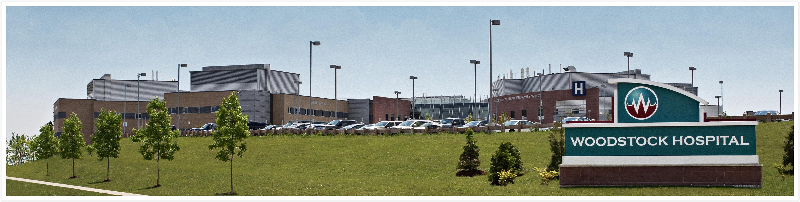

Table of Contents

1. Our Organization 1
1.1 Introduction 1
1.2 Facility Overview 1
1.3 Organizational Profile 2
1.4 Woodstock Hospital Building Summary 3
1.4.1 Central Plant 3
1.4.2 Combined Heat and Power Plant 3
1.4.3 Air Distribution 3
1.4.4 Hours of Operation and Occupancy 4
1.4.5 Lighting 4
1.4.6 Domestic Water Services 4
1.5 Floor Areas of Facilities 4
2. our Goals and objectives for conserving energy 5
2.1 Specific Targets and Goals 5
2.2 Energy Management Vision 5
2.3 Citizenship Policy 6
2.4 Why Energy Management is Important to Us? 6
3. baseline energy consumption and savings to date 7
3.1 Woodstock Hospital 7
3.2 Woodstock Hospital Medical Professional Building - 333 Athlone Ave. Woodstock 9
4. understanDing our current situation 11
4.1 Woodstock Hospital Energy Consumption and Costs 11
4.2 Woodstock Hospital Medical Professional Building Energy Consumption and Cost 12
4.3 Woodstock Hospital Finkle Medical Centre Energy Consumption and Cost 12
5. Current and proposed energy conservation and demand management measures 14
5.1 Proposed Future Projects 14
Demand Control Ventilation for Operating Rooms 14
VAV System Installation on AHU-20 14
LED Lighting Retrofits 14
5.2 Behaviour & Education 15
Environmental Advisory Committee 15
5.3 Summary Chart 16

Our Organization

Introduction
Ontario Regulation 25/23: Broader Public Sector: Energy Reporting and Conservation and Demand Management Plans requires Broader Public Sector (BPS) organizations to develop an Energy Conservation and Demand Management (CDM) plan and update it every five years. The Woodstock Hospital CDM plan was developed in compliance with the regulation and covers the period from 2025 to 2029. The plan has been reviewed and approved by Woodstock Hospital’s senior management.

The purpose of the Woodstock Hospital (WH) energy management plan and policies is to promote good stewardship of our environment and community resources. In keeping with the hospital’s vision to ensure patient care in an environmentally responsible and sustainable facility, Woodstock Hospital’s energy management program will reduce operating costs, which will enable WH to provide a progressive community hospital, delivering compassionate patient care and quality services by exceptional people.

Facility Overview
After construction of the hospital was complete, WH applied for and achieved LEED (Leadership in Energy and Environmental Design) certification at the silver level through the CaGBC (Canada Green Building Council), the first in Canada to reach this level. This certification was attained due to the hospital’s energy efficiency, water conservation, selection of materials, construction practices that minimize environmental impacts, recycling and improved indoor air quality for building occupants. It is also noteworthy that Woodstock Hospital was the first new hospital projects in Canada where the team was able to achieve an Innovation and Design Process LEED point for “Places of Respite”, with its central courtyard and continuous corridor design creating a high quality healing atmosphere for patients, visitors and staff.

In 2013, the Ontario Hospital Association (OHA) implemented a new program called the “Green Hospital Scorecard” which aims to reflect a hospital’s environmental performance as indicated by their operations, management and policies. The Green Hospital Scorecard assists hospitals in benchmarking their year-over-year performance; compares their performance to their peers; and encourages improvement and leadership through an established recognition program. Metrics collected online include nine categories: Energy, Water, Waste, Pollution Prevention, Corporate Leadership, Transportation, Food, Climate Change, and Anaesthetic Gas. Scorecards are created using the submitted data and presented to participating hospitals on a yearly basis. WH has participated in this program since the programs inception and will continue to do so to allow for benchmarking of this data to be used for year over year improvement. Woodstock Hospital has been nominated for the green hospital of the year 2 times and received an honourable mention for pollution prevention.

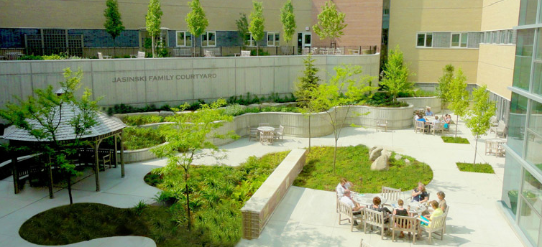

Organizational Profile
Organization Profile
P | Sector |  | ◻ | Government
E |  |  | ◻ | Education
O |  |  | ◻ | Health
P |  |  | ◻ | Commercial (_____________________)
L |  |  | ◻ | Other (_____________________)
E | Number of Employees ** |  | 1097 hospital staff including 584 PTE and 513 FTE
 | List of stakeholders |  | WH Staff;  WH Visitors;  Woodstock and surrounding community |  | Number of Buildings |  | Three (3) Facilities:  - Woodstock Hospital  - 333 Athlone Ave.  - 645 Finkle St.
 | Executive Support |  | Perry Lang |  | Energy Managers |  | Tyler Hall and Ryan Wood
 | Energy Committee |  | Utilities Management Subcommittee |  | Energy Volunteers |  | None
O | Energy Management Issues / Obstacles |  | ▪ Need to ensure CSA airflows being met at all times.
P |  |  | ▪ Occupants sometimes use operable windows during really cold or really hot weather.
E |  |  | ▪ Operating room AHU runs at full flow overnight when operating rooms not in use.
R |  |  | ▪ Ongoing discussions between WH and Project Co on various sequences of operation and commissioning approach to the facility
I | Business Year |  | April - March
O | Budget Cycle |  | April - March
N | Energy Year |  | January - December
S | Maintenance & Operations Budget* | 2024 | 2025 |  | 2026 | 2027 | 2028 | 2029 | 2030
 | Maintenance & Operations Budget* | $5,565,881 | $5,250,000 |  | $5,355,000 | $5,462,100 | $5,571,342 | $5,682,769 | $5,796,424
 | Utilities budget | 2024 | 2025 |  | 2026 | 2027 | 2028 | 2029 | 2030
 | Utilities budget | $1,459,664 | $1,657,000 |  | $1,770,400 | 1,896,867 | 2,038,213 | 2,196,518 | 2,374,167
 | Capital Budget*** | 2024 | 2025 |  | 2026 | 2027 | 2028 | 2029 | 2030
 | Capital Budget*** | $14,150,603 | - |  | - | - | - | - | -
*2024 and beyond budgets will be adjusted based on CPI and other factors pursuant to the Project Co-WH contract and so are subject to change
**WH FTE &PTE only; volunteers, contracted staff, & contractors not included
***Capital Budgets are determined on a yearly basis

Woodstock Hospital Building Summary

Central Plant
The central plant uses hydronic heating and cooling systems for the facility.

A chilled water system provides cooling to the facility utilizing a three tiered equipment approach to save energy and provide cooling more efficiently dependant on the weather season. The main system utilizes two 600 ton water-cooled centrifugal chillers, coupled with a two-cell induced draft cooling towers, to provide the necessary cooling during normal conditions through the summer. During electrical utility outages and through the shoulder seasons, two 155 ton air cooled screw chillers provide cooling to the building. Throughout the winter, a 101 ton dry cooler system coupled with a plate and frame heat exchanger provides all the chilled water production required for the facility.

The facility is heated by a dual fuel hydronic heating system. The system has two condensing boilers and three flex tube boilers, providing heat to the facility via air handing unit heating coils, ducted reheat coils, and radiant panels. The stairwell and exterior doorways are heated by cabinet unit heaters. Air curtains are provided at 4 of the main floor entrances. The central heating system is also used to operate snow melt systems underneath the walkway at three entrances (front, south, and ambulance bay) to prevent ice and snow build-up.

Combined Heat and Power Plant
In 2019 WH added a 999 kW Combined Heat and Power (CHP) plant. The system operates using natural gas to generate electricity, while efficiently repurposing the exhaust heat to supply the hospital with hot water for heating loads. The plant is expected to deliver a return on investment within the first five years and has a lifespan exceeding 20 years. This cogeneration plant effectively reduces the electrical demand of the facility on the grid and allows heat generation as a bi-product to reduce natural gas boiler usage.

Air Distribution
The facility has 22 air handling units (AHU). Each AHU, except for AHU19 has a supply fan, return fan, glycol heating/cooling coil, atomizing humidification unit, and outside air economizer. AHU01 has a heat pipe heat recovery coil.

AHU19 is used for Boiler Room make-up air only. It is equipped with a supply fan, glycol heating coil, and outside air economizer.

AHU17 is variable volume systems with VAV boxes with hot water reheat coils. This AHU serves the Administration area, and operates as a true VAV system, with a nightly setback and thermostats equipped with occupancy buttons.

AHU01 is a variable air volume system which serves our operating room area and was originally operated with 100% outdoor air. As part of our recommissioning in 2014 & 2015, AHU01’s operation was revised to use 30% outdoor air as permitted by a change in CSA Z217.2. The unit operates as constant volume system, with terminal boxes used to maintain positive pressure with respect to surrounding spaces.

The remaining quantity (19) AHU’s are constant air volume systems at this time.

Hours of Operation and Occupancy
The majority of the main hospital facility currently operate 24 hours 7 days a week with only Administration areas operating on a schedule of 7:00 – 19:00 during the week.

Lighting
Indoor lighting is primarily provided by compact fluorescent lamps, T5 lamps, and T8 lamps. The T5 and T8 lamps are powered by low ballast factor electronic ballasts. Occupancy controls and daylight controls are applied wherever suitable.

Outdoor lighting is provided by Metal Halide fixtures. They are controlled by either time clock or photocell as appropriate. In 2021 the hospital upgraded the outdoor lighting at the Medical Professional Building to LED lights.

Domestic Water Services
The facility has a natural gas DHW system with 2 x 950 Litre storage capacity, and a propane DHW system with 1 x 950 Litre storage capacity. The propane system is used for back-up only in case of temporary unavailability of natural gas.

Floor Areas of Facilities
WH operates three facilities:
- The main Woodstock Hospital at 310 Juliana Drive in Woodstock, ON
- The Woodstock Medical Professional Building at 333 Athlone Ave. in Woodstock, ON
- The Woodstock Medical Centre at 645 Finkle St. in Woodstock, ON which was recently purchased in February of 2023.

Operation Name | Operation Type | Address | Total Floor Area | Unit | Avg hrs/wk
WH - Medical Building | Administrative offices and related facilities | 333 Athlone Ave | 2,497.00 | Square meters | 50
WH - New Site Administrative | Administrative offices and related facilities | 310 Juliana Street | 2,678.00 | Square meters | 60
WH - New Site | Facilities used for hospital purposes | 310 Juliana Street | 29,838.00 | Square meters | 168
WH –Finkle Street Medical Centre | Administrative offices and related facilities | 645 Finkle Street | 3,283.20 | Square meters | 56

our Goals and objectives for conserving energy

Specific Targets and Goals
Our targets towards achieving our goals and objectives include:
• Reduce overall energy consumption of facilities by 1% over five years (2025-2029)
• Reduce electrical consumption by 2.5% over five years (2025-2029)
• Reduce natural gas consumption by 1% over five years (2025-2029)
• Reduce corporate facility GHG emissions by 1% over five years (2025-2029)

Energy Management Vision
The Woodstock Hospital plays a critical role in providing patient care to Oxford County and the surrounding area. In recognition of the correlation between public health and environmental health, Woodstock Hospital’s energy management plan will help limit the adverse impacts upon the environment through the facility’s design and operation. Our commitment to energy management is rooted in innovation, collaboration, and continuous improvement.

Woodstock Hospital strives to:

- Continuously improve through regularly monitoring and evaluation of our energy performance, and implementing progressive technologies and practices to minimize energy consumption across all hospital operations. This includes upgrading HVAC systems, lighting, and adopting renewable energy solutions where feasible.

- Promote environmental sustainability and reduce our carbon footprint by integrating sustainable practices into our daily operations. This includes waste reduction initiatives, green building design principles, and promoting energy conservation behaviors among staff and patients.

- Enhance patient care by prioritizing patient comfort and safety through efficient heating, cooling, and lighting systems that support healing environments while maintaining cost-effective energy management.

- Lead by example serving as a community leader in energy management and sustainability, sharing our successes and collaborating with local stakeholders and hospital staff to foster a culture of environmental responsibility. See Appendix C for more information on WH’s Green Team.

- Utilize strategic partnerships to purchase utilities in order to ensure that lowest cost is achieved. Informed procurement methods will also be utilized to acquire more energy efficient devices and technologies for the hospital going forward.

Through these efforts, Woodstock Hospital with its partner Project Co, is committed to consuming energy in an efficient, cost effective, environmentally responsible manner. It is recognized that utility costs are necessary to operate the facility but do not directly contribute to the quality of services offered in the facility. As such, as utility costs rise, it is imperative to reduce energy consumption in order to continue to provide services at or exceeding current standards.

Citizenship Policy
The Mission, Vision, and Values statements of Woodstock Hospital can be found at:
https://www.woodstockhospital.ca/mission-vision-values/
Honeywell’s Corporate Citizenship Report including sustainability can be found at:
Corporate_Citizenship_Report.pdf (honeywell.com)
Honeywell’s Environmental Social Governance Report can be found at:
ESG Report (honeywell.com)

Why Energy Management is Important to Us?
Energy Management is important at Woodstock Hospital because:
- Efficient energy practices reduce operational costs, allowing more resources to be allocated to patient care and facility improvements.
- WH strives to be a community leader in all aspects of our operations including the environmental sector. Being a leader means leading by example and being proactive in our operations.
- As utility prices rise, lower energy consumption is key to keeping energy costs manageable.
- Minimizing energy consumption reduces the hospital's carbon footprint, contributing to environmental sustainability and community health.
- WH believes a healthy building creates healthy patients. As a LEED Silver Facility and we want to maintain our place of respite for patients.
- The Government of Ontario has repealed the Green Energy Act, 2009, O. Reg. 397/11 (Energy Conservation and Demand Management Plans) and its purpose was moved to the Electricity Act, 1998 and re-named as O. Reg. 507/18, which requires all public sector (BPS) organizations to create conservation and demand management plans.

baseline energy consumption and savings to date

Woodstock Hospital
Year | Electricity (kWh) | Natural Gas (m³) | GHG Emissions (kgCO2e)
2018 | 10,172,500.81 | 1,312,118.14 | 2,825,753.97
2023 | 2,326,724.85 | 2,456,716.70 | 4,789,154.53
Variation | -77% | +47% | +41%

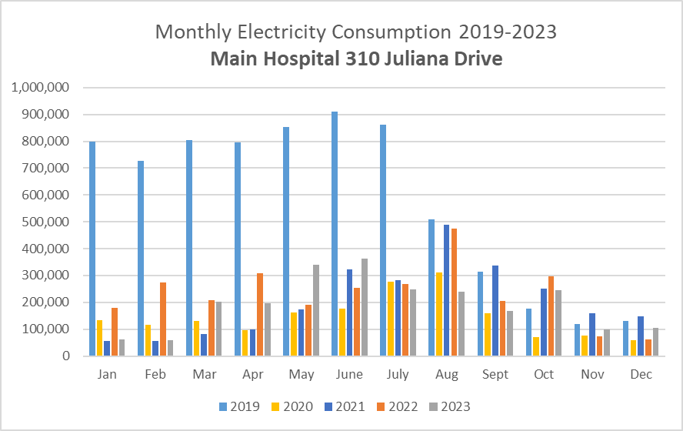

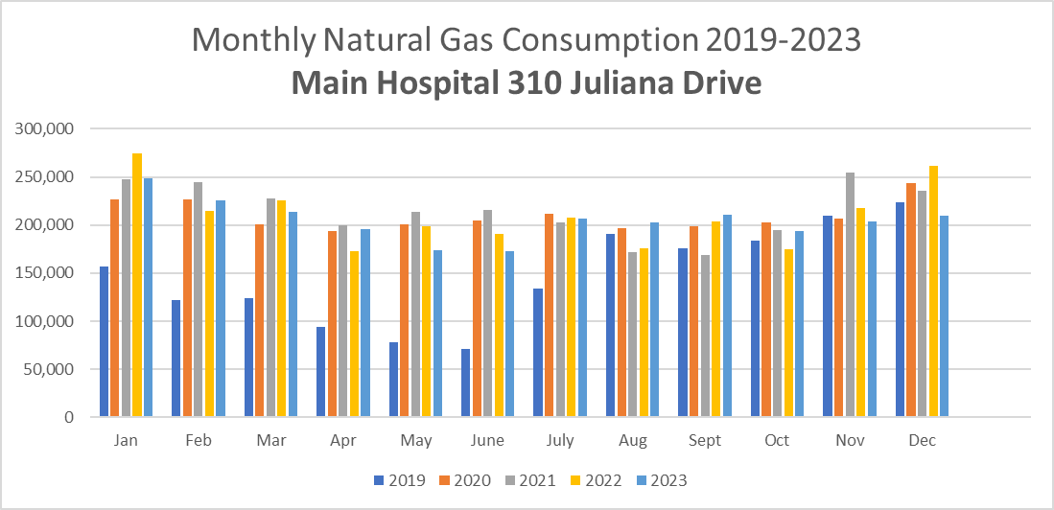

Combined Heat and Power (CHP) Plant
In August 2019 the Woodstock Hospital commissioned a CHP plant, which is capable of generating heat and electric power, while operationg at a total system efficiency of up to 71%. Electric power is generated on site through a natural gas generator. Simultaneously hot exhaust given off from the combustion of the natural gas in the engine will be harnessed for heating domestic hot water and the cental facility heating loop.

This electric power produced by the CHP has been suppling the hospital with 75.8% of the building’s electrical needs on average, which is approximately 27,423 GJ of annual electricity. This is the largest benefit of this project implementation resulting in significantly reduced electrical consumption and demand costs.

The CHP plant utilizes natural gas to operate, resulting in an average annual consumption of approximately 74,436 GJ of natural gas. This additional natural gas consumption is offset by the reduction in natural gas consumption by the building heating boilers, and domestic hot water heating systems. The CHP outputs an average of 21,789 GJ of recovered heat back to the central heating plant resulting in reduced operation of boilers and the domestic hot water heaters.

Other costs related to the operation of the CHP include the annual non-fuel operating and maintenance costs, as well as demand standby fees. Reviewing the annual operations costs, as well as the CHP’s output and average utility costs since 2019, the financial benefit of the CHP is calculated to be on average $755,800 annually resulting in a simple project payback period of 4.33 years. The anticipated life of the CHP plant is up to 20 years.

Woodstock Hospital Medical Professional Building - 333 Athlone Ave. Woodstock
Year | Electricity (kWh) | Natural Gas (m³) | GHG Emissions (kgCO2e)
2018 | 301,671.3 | 44,399.6 | 94,341.7
2023 | 255,836.03 | 34,989.00 | 74,888.95
Variation | -15% | -21% | -21%

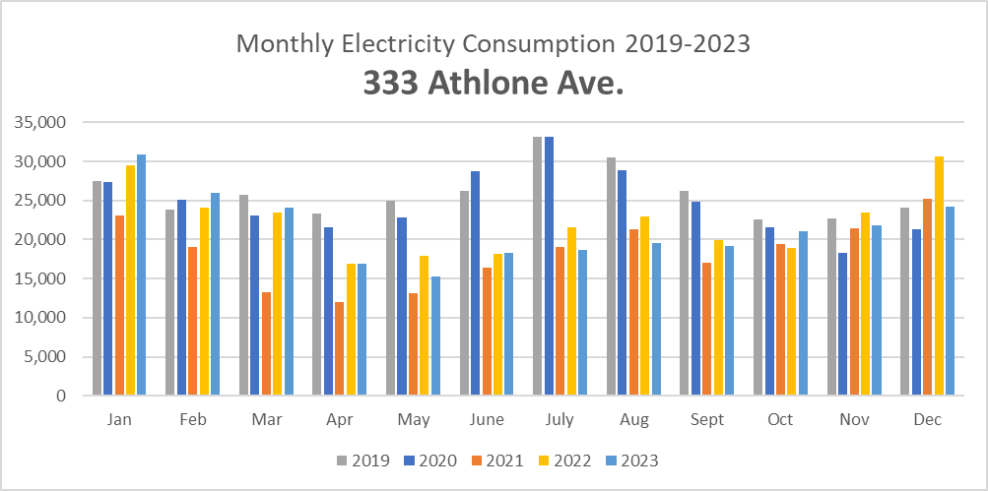

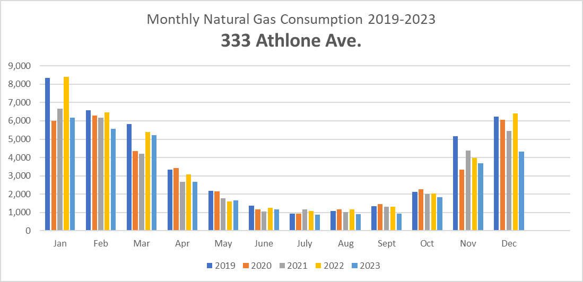

Solar PV Generation

In December 2020 Woodstock Hospital installed a 134kWDC Rooftop Solar Array on the 333 Athlone Medical Professional Building. This is a net metered solar panel system, which allows WH to collect a credit for the amount of kWh the solar panels produce and allows us to use the credit to offset our monthly utility bill.

Based on the yearly production data taking into account panel degradation and OER rebates, a payback is estimated at this time for just over 11 years.

This PV system annual generation statistics are listed in the table below:

Year | Electricity Produced (kWh) | Cost Savings
2021 | 148,828 | $26,957.63
2022 | 156,180 | $28,273.64
2023 | 154,618 | $27,702.26

Exterior LED Lighting Retrofit

In April 2021 Woodstock Hospital installed several exterior LED lights on the exterior of the 333 Athlone Medical Professional Building as well as in the parking lot. These LED lights repalced standard floressent bulbs, T8 and T5 balasted lamps, and metal halide fixtures in the parking lot saving not only appoxiamately 17,500 kWh in electricity annually but also operational costs to replace light bulbs. This excersise cost a total of $18,455.00 in capital investment however with rebate incentives shows a 6 year simple payback period.

understanDing our current situation

Woodstock Hospital Energy Consumption and Costs

Utility | Units Consumed |  | GHG Emissions (kgCO2e)
(Jan-Dec 2023) |  |  | GHG Emissions (kgCO2e)
Electricity | 2,326,725 | kWh | 69,801.75
Natural gas | 2,456,717 | m³ | 4,719,352.78
Water | 65,483 | m³ | N/A
Oil | 9,736 | L | 26,803.20
Propane | 1,841 | L | 2,789.10
Total |  |  | 4,818,746.83

Woodstock Hospital Utility Costs 2023

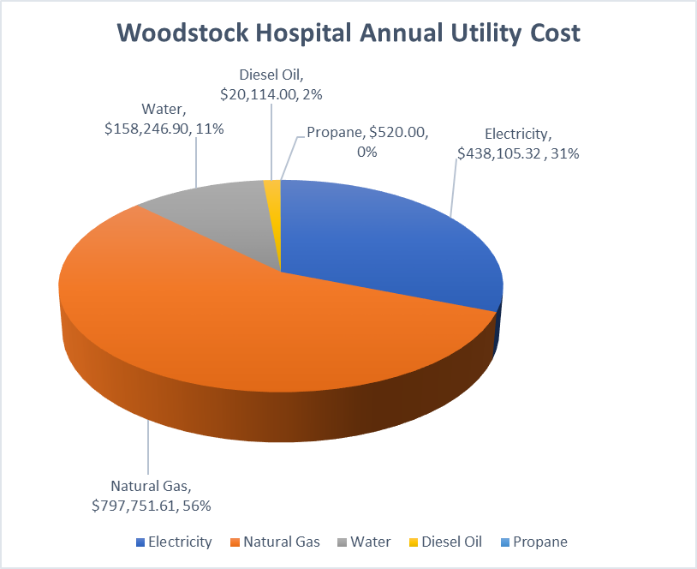

333 Athlone Ave. Medical Professional Building Energy Consumption and Cost
Utility | Units Consumed |  | GHG Emissions (kgCO2e)
(Jan-Dec 2023) |  |  | GHG Emissions (kgCO2e)
Electricity | 255,836 | kWh | 7,675.08
Natural gas | 34,989 | m³ | 67,213.87
Water | 528 | m³ | N/A
Total |  |  | 74,888.95

Medical Professional Building Utility Costs 2023

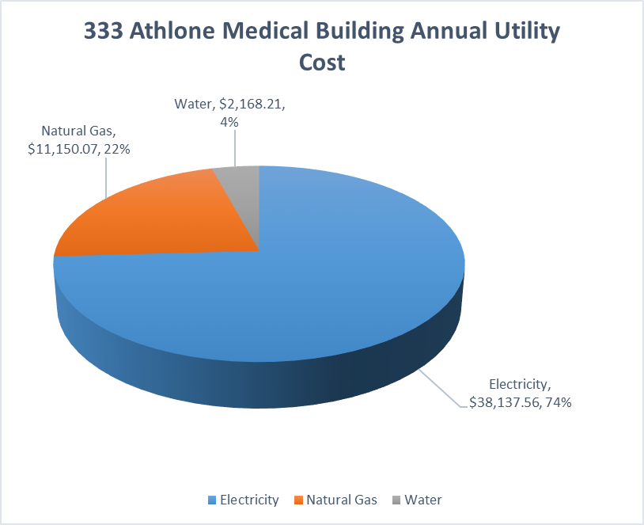

645 Finkle St. Medical Centre Energy Consumption and Cost

Utility | Units Consumed |  | GHG Emissions (kgCO2e)
(Jan-Dec 2023) |  |  | GHG Emissions (kgCO2e)
Electricity | 135,346 | kWh | 4,060.38
Natural gas | 25,853 | m³ | 49,663.61
Water | 165 | m³ | N/A
Total |  |  | 53,723.99

Finkle St. Woodstock Medical Centre Utility Costs 2023

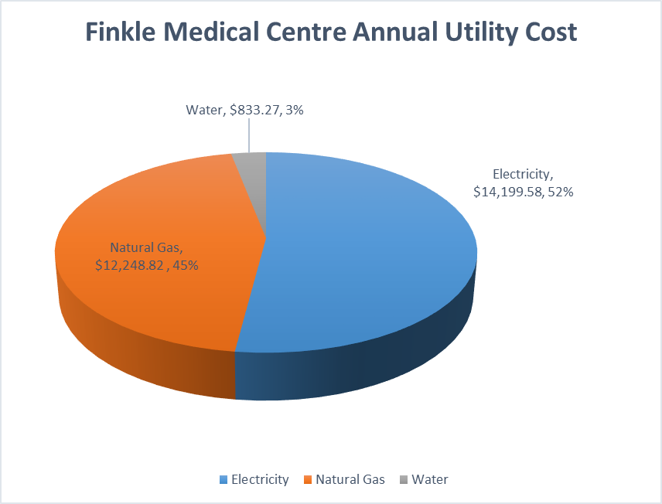

Current and proposed energy conservation and demand management measures

Proposed Future Projects

Demand Control Ventilation for Operating Rooms
Woodstock Hospital is proposing to install demand control ventilation in five operating rooms (ORs) and the post-anesthetic care unit (PACU), to provide the ability to safely perform procedures on patients with communicable illnesses, such as COVID-19, and as an energy reduction measure. Operating rooms are positively pressurized and require high air-change rates when in use to create a clean sterile environment, which is energy intensive. Currently when the rooms are not in use, the air change rates do not decrease, and their pressurization cannot be changed.

The proposed demand controlled ventilation would be accomplished through the installation of Venturi style air valves and associated controls on each room's supply and return air ducts. When the rooms are occupied, the Venturi air valves would reduce the air flow, while maintaining the offset and pressurization on the supply and return. Additionally, these changes would permit each of the ORs to be utilized for treating patients with contagious illnesses, such as COVID-19, by providing the necessary negative pressurization compared to adjacent spaces and using 100% outdoor air. In regular operation, the project will reduce the demand on the chillers, boilers, and reheat coils, serving the operating rooms and continuing to meet the temperature and pressurization requirements as stipulated by CSA-Z317.2. The savings will be reduced with the added functionality to perform airborne isolation procedures. With reduced air flow going to the ORs and PACU, less cooling and heating is required to condition the air being supplied, resulting in a hydro and natural gas consumption reduction, and a reduction in GHG produced.

Currently the existing air handling unit (AHU-1) operates at 19,536 cfm and 30% outside air (OA) 24 hours per day, 7 days per week. To preserve energy, the operating schedule for the existing AHU-1 is proposed to be modified such that it operates according to the schedule shown below:
- 13,024 cfm and 30% OA from 8:00 pm - 6:00 am Monday to Friday, and on weekends.
- 19,536 cfm and 30% OA at all other times.

VAV System Installation on AHU-20
Woodstock Hospital’s chemotherapy department only operates Monday – Friday from 7:00 – 17:00. During the unoccupied hours the current constant volume system is supplying air volumes to the unoccupied space well above minimum requirements and wasting valuable energy resources. By implementing a variable air volume system the WH will be able to reduce tempered air supply to unoccupied spaces and save on utilities resources.

LED Lighting Retrofits
The Woodstock Hospital and the Medical Professional Building at 333 Athlone Ave. both still utilize standard compact fluorescent lamps and ballasted T-5 and T-8 lamps for the majority of interior lighting. In converting to LED lighting fixtures or retrofitting the current fixtures with LED components, the hospital plans to not only significantly reduce electrical energy consumption, but also save costs on the maintenance required to change ballasts and bulbs as they expire.

There seems to be significant utility savings associated with these LED retrofit activities but due to the nature of the Hospital’s P3 contract, this is only a proposed project and at the time of publish of this report approval to proceed was not yet agreed.

Behaviour & Education

Environmental Advisory Committee
Every year WH holds an Earth Day celebration hosted by the Environmental Advisory Committee. The day involves collaborating with our community partners and local businesses. The event is held similar to a trade show with around 10 booths in our cafeteria. Participants include Oxford County, City of Woodstock, Upper Thames Conservation Authority, Arntjen Solar and Charger Crew and many more. The goal of the event is to educate staff, patients and the community on what it going on around them and what they can do at home to reduce their impact on the environment. This also offers WH the opportunity to provide some staff education and inform the public on Waste best practices, to increase waste reduction, as well as inform staff and public of energy best practices.

The hospital works with many community partners that aid in environmental initiatives including the Smart Energy Oxford Committee, who is constantly looking at new technologies, policies and renewable projects to meet their goal of a 100% renewable by 2050. The committee is composed of county and city workers, industry partners such as Toyota and GM, renewable energy contractors and various engineers and several mayors.

WH offers its staff various opportunities, on site, to take advantage of alternate and environmentally considerate means of transportation. The property has 38 exterior bike racks and recently provided 10 interior bike racks. With large amount of bicycle storage at all entrances, biking to work is convenient. If staff are afraid of theft, we offer secure indoor bike storage in a camera monitored room. The hospital also offers locker and shower facilities to staff wishing to bike, walk or jog to work. We also have a local bus routes with two stops on the hospital property and is working with another city to provide a cross-county public bus route to provide staff and patients an alternate transportation option throughout the county. 23 electric car chargers are located at our various buildings to accommodate staff and visitors with EVs and PHEVs.

Completed Projects
Project Name | Description | Annual Potential Electrical Savings (kWh) | Potential Natural Gas Savings (GJ) | Potential Cost Savings (Energy + Operational) | Total Cost | Incentive | Projected Simple Payback | Next Steps
CHP Plant | Construction of a Combined Heat and Power (CHP) Plant | 7,617,500 | NA | $755,797.62 | $4,782,650.40 | $1,590,033.00 | 4.33 Yrs | Completed
Medical Building Rooftop Net Metered Solar Power Generation | Install solar panels on the roof of the Medical Building to generate electricity to offset utility cost | 148,828 | NA | $28,028.80 | $273,100 | Average OER Savings of $5,435.89 annually | 10 Yrs | Completed
LED Lighting Retrofit | Replace exterior and 24hr interior light fixtures with LED fixtures | 17,500 | NA | $3,200 | $18,455.00 | $1,564.90 | 6 Yrs | Completed
Scheduled Projects
Demand Control Ventilation for Operating Rooms | Utilize a VAV system with venturi valves to modulate supply and return air in ORs and PACU | 172,013.00 | 431 | $30,205.72 | $260,000 | N/A | 8.6 Yrs | Searching for Incentive program funding to complete. Capital budget approved contingent of supplemental funding.
VAV System Installation on AHU-20 | Utilize a conventional VAV system to allow unoccupied setbacks | 72,275.40 | 288 | $12,717.40 | $100,000 | $1,444.00 | 7.8 Yrs | Engineered Drawings completed, tender completed, waiting to be installed.
Proposed Projects
Hospital Interior LED Lighting Retrofit | Replace main hospital interior lights which are currently compact fluorescent lamp fixtures to LED | 1,585,077 | N/A | $354,913 | $1,334,182.00 | N/A | 3.8 Yrs | Detailed study and pricing obtained. Now preliminary discussion phase.
Hospital Exterior LED Lighting Retrofit | Replace main hospital parking lot lights which are metal halide fixtures to LED | 32,266 | N/A | $14,267.63 | $114,100.00 | N/A | 8 Yrs | Detailed study and pricing obtained. Now preliminary discussion phase.
333 Athlone Medical Building Interior LED Lighting Retrofit | Replace medical building interior lights which are currently compact fluorescent lamp fixtures to LED | 46,959 | N/A | $10,714 | $68,235.74 | N/A | 6.4 Yrs | Detailed study and pricing obtained. Now preliminary discussion phase.
Continuous Programs
Sequences | Daily review of manual settings on building systems |  |  |  |  |  | Immediate | On-going
Continuous Commissioning | Quarterly Utilities Subcommittee |  |  |  |  |  |  | Meet to review building operations, and identify future potential energy saving opportunities
Behavioural/Education Programs
Energy Awareness | Environmental Advisory Committee & Annual Earth Day Event |  |  |  |  |  |  | Occupant awareness of energy consumption, get staff interested and excited about saving energy.

Summary Chart

